INDEX

Sl No | Name of the program | Date | Page No | Remarks
1 | Create your class time table using table tag |  | 3
2 | ‭Design‬ ‭a‬ ‭Webpage‬ ‭for‬ ‭your‬ ‭college‬ ‭containing‬ ‭description‬ ‭of‬ ‭courses,‬  department, faculties, library etc. using list tags, href tags, and anchor tags |  | 7
3 | Create Your Resume using HTML. Use text, link, and lists |  | 13
4 | ‭Create a Web Page of a supermarket using (internal CSS) |  | 17
5 | Use Inline CSS to format your resume that you have created |  | 21
6 | ‭Use External CSS to format your time table created |  | 25
7 | Use‬ ‭all‬ ‭the‬ ‭CSS‬ ‭(inline,‬ ‭internal‬ ‭and‬ ‭external)‬ ‭to‬ ‭format‬ ‭the‬ ‭college‬ ‭web‬  page that you have created |  | 31
8 | Write a HTML Program to create your college website for mobile device |  | 39
9 | Write an HTML/JavaScript page to create a login page with validations |  | 47
10 | Develop‬‭ a‬‭ Simple‬‭ calculator‬‭ for‬‭ addition,‬‭ subtraction,‬‭ multiplication‬‭ and‬  division operation using JavaScript |  | 51
11 | Use Regular Expressions for validations in Login Page using JavaScript |  | 55
12 | Write‬ ‭a‬ ‭Program‬ ‭to‬ ‭retrieve‬ ‭date‬ ‭from‬ ‭a‬ ‭text‬ ‭file‬ ‭and‬ ‭display‬ ‭it‬ ‭using‬ AJAX |  | 57
13 | Create‬ ‭a‬ ‭web‬ ‭page‬ ‭using ‬‭Frame‬‭ with‬‭ rows ‬‭and‬‭ columns ‬‭where‬‭ we ‬‭will‬ have‬ ‭header‬ ‭frame,‬ ‭left‬ ‭frame,‬ ‭right‬ ‭frame,‬ ‭and‬ ‭status‬ ‭bar‬ ‭frame.‬ ‭On‬ clicking in the left frame, information should be displayed in the right frame |  | 59

Program 1

Aim

Create your class time table using table tag

Program

<!DOCTYPE html>
<html>
<head>
<title>BCA SEM 2 Time Table</title>
</head>
<body class="body">
<div id="header">
<h1>Timetable for BCA Sem II</h1>
</div>
<div>
<table border="5">
<div id="caption">
<caption>BCA Sem II Timetable</caption>
</div>
<tr>
<th></th>
<th>Hour 1</th>
<th>Hour 2</th>
<th>Hour 3</th>
<th>Hour 4</th>
<th>Hour 5</th>
</tr>
<tr>
<th>Day 1</th>
<td>Data Structures</td>
<td>Operating Systems</td>
<td>Indian Constitution</td>
<td>Web Technologies Lab</td>
<td>Web Technologies Lab</td>
</tr>
<tr>
<th>Day 2</th>
<td>Hindi/Malayalam</td>
<td>Data Structures</td>
<td>Operating Systems</td>
<td>Maths</td>
<td>Maths</td>
</tr>
<tr>
<th>Day 3</th>
<td>Data Structures</td>
<td>English</td>
<td>Hindi/Malayalam</td>
<td>Web Technologies</td>
<td>Operating Systems</td>
</tr>
<tr>
<th>Day 4</th>
<td>Operating Systems</td>
<td>Maths</td>
<td>Indian Constitution</td>
<td>English</td>
<td>Hindi/Malayalam</td>
</tr>
<tr>
<th>Day 5</th>
<td>Data Structures</td>
<td>Maths</td>
<td>English</td>
<td>Data Structors Lab</td>
<td>Data Structors Lab</td>
</tr>
</table>
</div>
</body>
</html>

Output

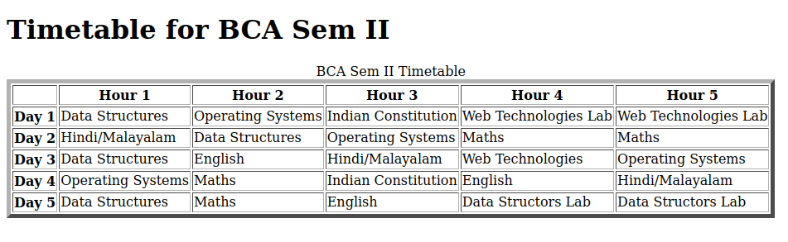

Program 2

Aim
Design‬ ‭a‬ ‭Webpage‬ ‭for‬ ‭your‬ ‭college‬ ‭containing‬ ‭description‬ ‭of‬ ‭courses,‬ department, faculties, library etc. using list tags, href tags, and anchor tags

Program

Popular repositories Loading

<!DOCTYPE HTML>
<html>
<head>
<meta name="viewport" content="width=device-width,initial-scale=1.0"/>
<title>St.George's College Aruvithura</title>
</head>
<body>
<div>
<h1>St.George's College Aruvithura</h1>
</div>
<hr>
<nav>
<ul>
<li> <a href="#about">About Our College</a> </li>
<li> <a href="#courses">Courses</a> </li>
<li> <a href="#departments">Departments</a> </li>
<li> <a href="#library">Library</a> </li>
<li> <a href="#location">Locate Us </a></li>
</ul>
<hr>

<div id="about">
<h3>About College</h3>

<marquee> <h5>Ensuring academic excellence by imparting quality education and moulding personalities based on the love of God <h5> </marquee>

<p>St. George's College Aruvithura is a college under Mahatma Gandhi University, Kottayam. It is located in Aruvithura, Erattupetta, Kottayam District in Kerala, India. It was reaccredited with 'A++' Grade by NAAC for seven years in the fourth cycle.</p>

<p>St. George’s College Aruvithura, is a minority educational institution founded by St. George Forane Church, Aruvithura in 1965. Pioneered under the patronage of His Excellency Mar Sebastian Vayalil, the first Bishop of Pala, and cherished by a host of visionaries and philanthropists like Very Rev. Fr. Thomas Araythinal and Mr T. A. Thomman (Former Minister), the college, right from its inception, embarked on an odyssey towards academic pre-eminence. Very Rev. Fr. Thomas Manakkat, the founding manager and a great visionary, was truly instrumental in laying the foundations for a great beginning and Very Rev. Fr. Jacob Thazhathel, who followed him, was equally adept and insightful in his ideals, guiding the college during the early stages of its growth. For more than two decades, His Excellency Mar Joseph Pallickaparampil, the Bishop of Pala, had been the patron of the college. His Excellency Mar Joseph Kallarangattu is the present patron of this seat of learning.</p>

<p>Now the College offers instruction in Arts, Science, and Commerce. As of now, we have 15 undergraduate courses namely, Chemistry, Mathematics, Physics, Botany, Economics, Political Science, Commerce, English and Food Science and Quality Control (Self Financing) B.Com [Co-operation (SF)], BCA (SF), BA Mass Communication and Journalism and Five Post Graduate courses in Chemistry and Physics, Mathematics (SF), M.Com (SF), and M.Sc. Food Science and Technology (SF). An Integrated M.A. Programme in Languages English is also conducted here. The parents of students and the local population have been extending unconditional support for the onward progress of the College.

The College aims at the overall development of the students which would enable them to become ideal citizens of our country. The management, the faculty, and all the members of the non - teaching staff spare no pains to give all possible help for the spiritual, intellectual, moral, and academic excellence of the students put under the care of St. George, the Heavenly Patron.</p>
</div>

<hr>

<div id="departments">
<h3>Departments</h3>

<ul>
<li> <a href="https://jzwn.github.io/BCA-LAB-Assignments/Lab/bca_dept.html" target="_blank"> Department of Computer Applications (Aided)</a></li>
<li> <a href="https://sgcaruvithura.ac.in/about-department?type=Department%20of%20Commerce%20(Aided)&department=13" target="_blank">Department of Commerce</a> </li>
<li> <a href="https://sgcaruvithura.ac.in/about-department?type=Department%20of%20Mathematics%20(SF)&department=31" target="_blank">Department of Mathematics</a> </li>
</ul>
</div>
<hr>
<div id="courses">
<h3>Courses Offered</h3>
<ol>
<li>Bachelor of Computer Applications (BCA)</li>
<li>B.Com (Honours) with Specialization in Finance & Taxation</li>
<li>B.Sc (Honours) Mathematics</li>
<li>B.Sc (Honours) Chemistry</li>
<li>B.Sc (Honours) Botany</li>
<li>B.A (Honours) Political Science</li>
<li>B.Voc Food Technology & Analysis</li>
<li>B.Com (Honours) with Specialization in Finance & Taxation</li>
<li>B A (Honours) English with Specialization in Media Studies & Film Studies </li>
<li>B.Sc (Honours) Physics with specialization in Computational Physics and Semiconductor Physics</li>
</ol>
</div>
<hr>
<div id="library">

<h3>Our Library</h3>

<p>The library at St. George's College, Aruvithura, has a rich history, having started functioning in 1965. Over the years, it has undergone significant upgrades and expansion to become a first-grade library. In 1978, the post of a first-grade Librarian and a IV-grade librarian were sanctioned, indicating the growing importance of the library as a vital academic resource.

Today, the library has a vast collection of resources to support the academic programs of the college. There are 32,330 books available on various subjects, including literature, science, technology, history, and philosophy. The library also has 58 periodicals, 250 CDs, and access to 8 newspapers, providing students and staff with access to the latest research and developments in their fields of interest.</p>
</div>
<hr>

<div id="location">
<h3>Locate Us</h3>
<br>
<iframe src="https://www.google.com/maps/embed?pb=!1m18!1m12!1m3!1d15731.91383638338!2d76.76682855568099!3d9.682879222712!2m3!1f0!2f0!3f0!3m2!1i1024!2i768!4f13.1!3m3!1m2!1s0x3b07cb05a55ae0e1%3A0x7b29e5e1e75aca3a!2sSt.%20George&#39;s%20Syro-Malabar%20Church%2C%20Aruvithura.!5e0!3m2!1sen!2sin!4v1739352757054!5m2!1sen!2sin" width="600" height="450" style="border:0;" allowfullscreen="" loading="lazy" referrerpolicy="no-referrer-when-downgrade"></iframe>
</div>

</body>
</html>

Output

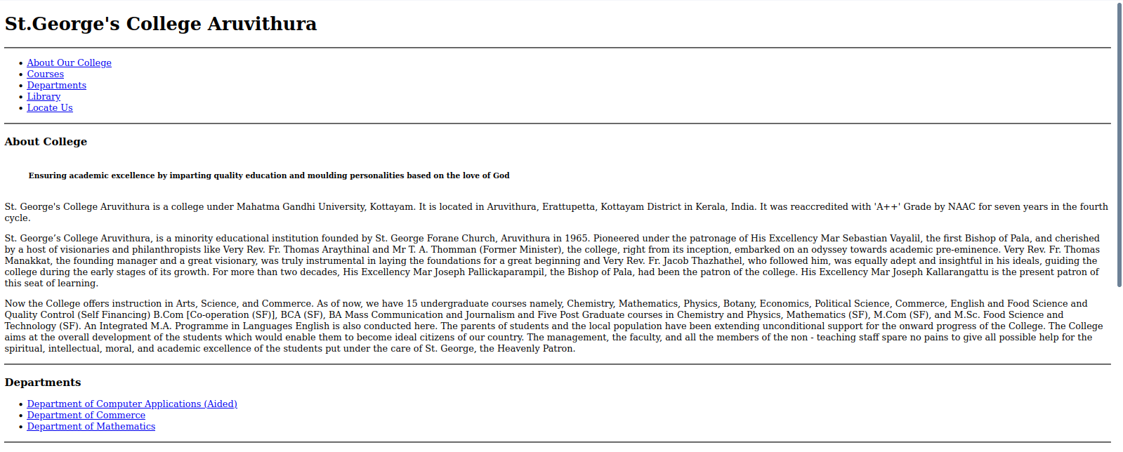
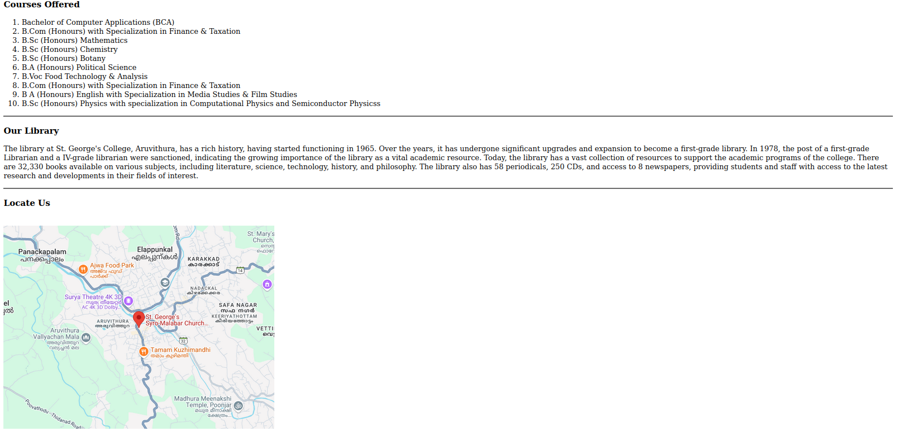

Program 3

Aim
Create Your Resume using HTML. Use text, link, and lists

Program

<!DOCTYPE html>
<html>
<head>
<title>Resume - Jeswin Joji</title>
</head>
<body>
<h1>Jeswin Joji</h1>
<hr>
<p>Email: <a href="mailto:hello@jeswinjoji.com">hello@jeswinjoji.com</a></p>
<p>Phone: (+91) 7345678900</p>
<p>Website: <a href="https://jeswinjoji.com">jeswinjoji.com</a></p>
<p>Stackoverflow: <a href="https://stackoverflow.com/users/15865278/jeswin-joji">stackoverflow.com/users/15865278/jeswin-joji</a></p>
<p>Github: <a href="https://github.com/jzwn">github.com/jzwn</a></p>
<p>LinkedIn: <a href="https://www.linkedin.com/in/jeswin-joji-b004591a2/">linkedin.com/in/jeswin-joji-b004591a2/</a></p>

<hr>
<h2>Education</h2>
<ul>
<li>Bachelor of Computer Applications, St.George's College Aruvithura</li>
<li>Commerce with Computer Applications, St.Mary's HSS Bharananganam</li>
</ul>
<hr>
<h2>Objectives</h2>

<p>To be a good developer & have success through cooperation and continuous learning, while contributing effectively to my team and organization.</p>

<hr>
<h2>Skills</h2>
<ul>
<li>Programming: (Basic) C/C++, Python, Java</li>
<li>Web Development: (Basic) JavaScript, HTML</li>
</ul>

<hr>
<h2>Languages</h2>
<ul>
<li>English</li>
<li>Malayalam</li>
<li>Spanish</li>
</ul>
<hr>
<h2>Hobbies/Activities</h2>
<ul>
<li>Listening Music</li>
<li>Watching Movies/Series</li>
</ul>
</body>
</html>

Output

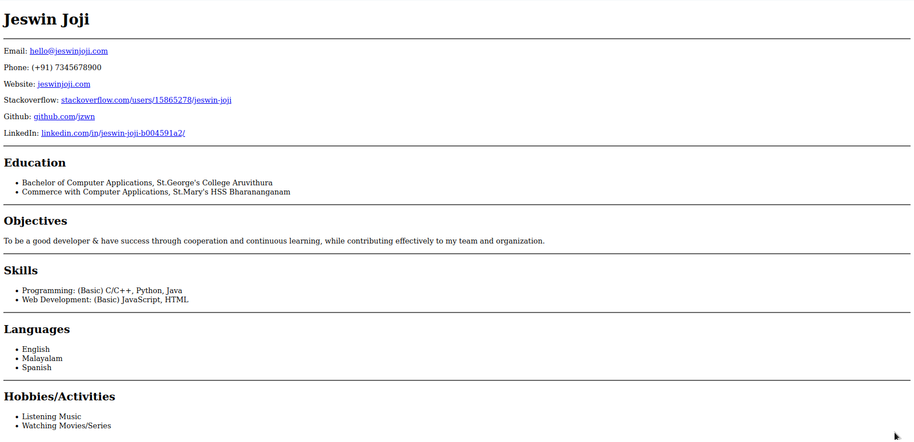

Program 4

Aim
Create a Web Page of a supermarket using (internal CSS)

Program

<!DOCTYPE html>
<html>
<head>
<title>ABC Hypermart</title>
<style>
body {
font-family: Arial, sans-serif;
background-color: #e0f7fa;
text-align: center;
}
.product {
width: 50%;
margin: 20px auto;
padding: 15px;
border: 1px solid #ddd;
background-color: #ffffff;
border-radius: 30px;
}
.product img {
width: 300px;
height: auto;
}
.add-to-cart {
margin-top: 10px;
padding: 8px 12px;
background-color: #008CBA;
color: white;
border: none;
border-radius: 30px;
}
.add-to-cart:hover {
background-color: #005f73;
}
.add-to-cart:active {
background-color: #003f5c;
}
header {
background-color: #004d40;
color: white;
padding: 15px;
}
footer {
margin-top: 20px;
padding: 10px;
background-color: #00796b;
color: white;
}
</style>
</head>
<body>
<div class="container">
<header>
<h1>ABC SuperMarts Network</h1>
<h3>Pala,Kottayam & Aruvithura</h3>
<p>Your one-stop shop for all grocery needs.</p>
</header>
<hr>

<h2>Featured Products</h2>
<div class="product">
<h3>Vegetables</h3>
<img src="https://jzwn.github.io/BCA-LAB-Assignments/Lab/Resources/pgm_4_vegetables.jpg" alt="Vegetables">
<p>Fresh and organic vegetables available daily.</p>
<button class="add-to-cart">Add to Cart</button>
</div>
<div class="product">
<h3>Dairy</h3>
<img src="https://jzwn.github.io/BCA-LAB-Assignments/Lab/Resources/pgm_4_diary_products.jpg" alt="Dairy">
<p>Milk, cheese, butter, and more dairy products.</p>
<button class="add-to-cart">Add to Cart</button>
</div>
<div class="product">
<h3>Groceries</h3>
<img src="https://jzwn.github.io/BCA-LAB-Assignments/Lab/Resources/pgm_4_groceries.jpg" alt="Groceries">
<p>All essential groceries for your daily needs.</p>
<button class="add-to-cart">Add to Cart</button>
</div>
<div class="product">
<h3>Gift Items</h3>
<img src="https://jzwn.github.io/BCA-LAB-Assignments/Lab/Resources/pgm_4_gift_items.jpg" alt="Gift Items">
<p>Perfect gifts for your loved ones.</p>
<button class="add-to-cart">Add to Cart</button>
</div>
<div class="product">
<h3>Ready to Cook</h3>
<img src="https://jzwn.github.io/BCA-LAB-Assignments/Lab/Resources/pgm_4_ready_to_cook_items.jpg" alt="Ready to Cook">
<p>Quick and easy meals for busy days.</p>
<button class="add-to-cart">Add to Cart</button>
</div>
</div>
<footer>
<p>ABC Super Marts</p>
</footer>
</body>
</html>

Output
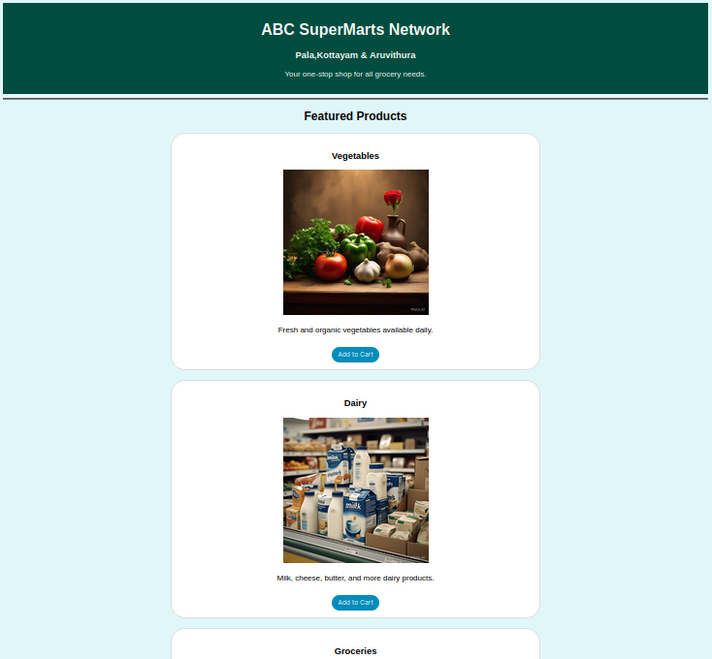
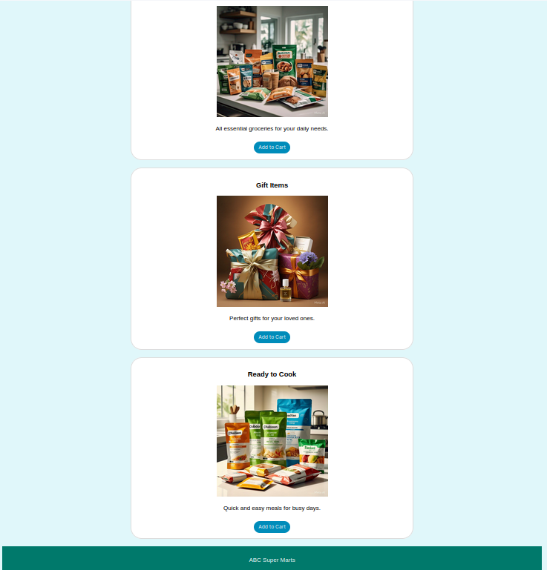

Program 5

Aim
Use Inline CSS to format your resume that you have created

Program

<!DOCTYPE html>
<html>
<head>
<title>Resume - Jeswin Joji</title>
</head>
<body style="font-family: Arial, sans-serif; max-width: 70%; margin: auto; background-color: #fdf5e2; padding: 20px; color: #333333;">

<h1 style="text-align: center; color: #222222;">Jeswin Joji</h1>

<hr style="border: 3px solid #cccccc;">
<p>Email: <a href="mailto:hello@jeswinjoji.com" style="color: #c76024;">hello@jeswinjoji.com</a></p>
<p>Phone: (+91) 7345678900</p>
<p>Website: <a href="https://jeswinjoji.com" style="color: #c76024;">jeswinjoji.com</a></p>
<p>Stackoverflow: <a href="https://stackoverflow.com/users/15865278/jeswin-joji" style="color: #c76024;">stackoverflow.com/users/15865278/jeswin-joji</a></p>
<p>Github: <a href="https://github.com/jzwn" style="color: #c76024;">github.com/jzwn</a></p>
<p>LinkedIn: <a href="https://www.linkedin.com/in/jeswin-joji-b004591a2/" style="color: #c76024;">linkedin.com/in/jeswin-joji-b004591a2/</a></p>

<hr style="border: 3px solid #cccccc;">
<h2 style="color: #444444;">Education</h2>
<ul>
<li>Bachelor of Computer Applications, St.George's College Aruvithura</li>
<li>Commerce with Computer Applications, St.Mary's HSS Bharananganam</li>
</ul>

<hr style="border: 3px solid #cccccc;">
<h2 style="color: #444444;">Objectives</h2>
<p>To be a good developer & have success through cooperation and continuous learning.</p>

<hr style="border: 3px solid #cccccc;">
<h2 style="color: #444444;">Skills</h2>
<ul>
<li>C/C++, Python, Java</li>
<li>JavaScript, HTML</li>
</ul>

<hr style="border: 3px solid #cccccc;">
<h2>Languages</h2>
<ul>
<li>English</li>
<li>Malayalam</li>
<li>Spanish</li>
</ul>

<hr style="border: 3px solid #cccccc;">
<h2 style="color: #444444;">Hobbies</h2>
<ul>
<li>Listening to Music</li>
<li>Watching Movies/Series</li>
</ul>
</body>
</html>

Output

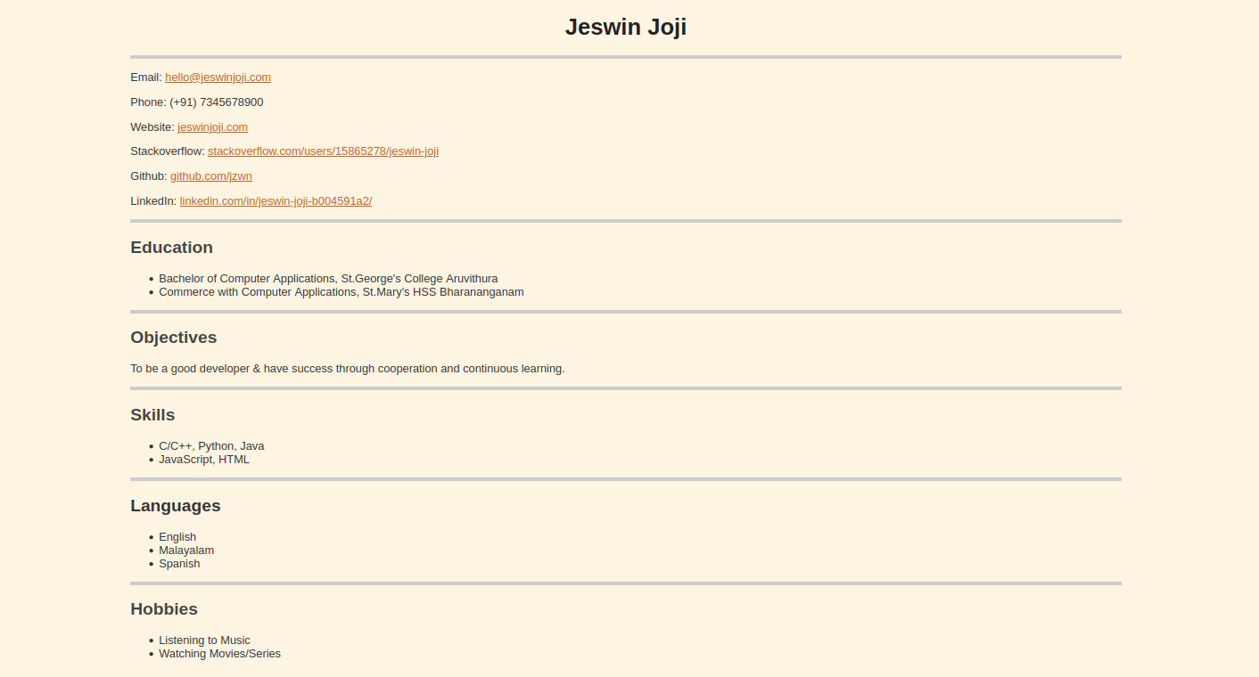

Program 6

Aim

Use External CSS to format your time table created

Program

HTML

<!DOCTYPE html>
<html>
<head>
<title>BCA SEM 1 Time Table</title>
<link rel="stylesheet" href="css/pgm_6_styles.css">
</head>

<body class="body">
<div id="header">
<h1>Time Table for BCA Sem II</h1>
</div>
<div>
<table border="5">
<div id="caption">
<caption>BCA Sem II Timetable</caption>
</div>
<tr>
<th></th>
<th>Hour 1</th>
<th>Hour 2</th>
<th>Hour 3</th>
<th>Hour 4</th>
<th>Hour 5</th>
</tr>
<tr>
<th>Day 1</th>
<td>Data Structures</td>
<td>Operating Systems</td>
<td>Indian Constitution</td>
<td>Web Technologies Lab</td>
<td>Web Technologies Lab</td>
</tr>
<tr>
<th>Day 2</th>
<td>Hindi/Malayalam</td>
<td>Data Structures</td>
<td>Operating Systems</td>
<td>Maths</td>
<td>Maths</td>
</tr>
<tr>
<th>Day 3</th>
<td>Data Structures</td>
<td>English</td>
<td>Hindi/Malayalam</td>
<td>Web Technologies</td>
<td>Operating Systems</td>
</tr>
<tr>
<th>Day 4</th>
<td>Operating Systems</td>
<td>Maths</td>
<td>Indian Constitution</td>
<td>English</td>
<td>Hindi/Malayalam</td>
</tr>
<tr>
<th>Day 5</th>
<td>Data Structures</td>
<td>Maths</td>
<td>English</td>
<td>Data Structors Lab</td>
<td>Data Structors Lab</td>
</tr>
</table>
</div>

<div id="footer">
<h3>Timetable 2025 | BCA Sem II</h3>
</div>
</body>
</html>

CSS

table {

width:100%;
border: 4px solid #00274D;
border-radius: 12px;
border-style: double;
color: #333;
background-color: #CAF1DE;
font-style: italic;
font-size: 24px;
font-family: Arial, sans-serif;
padding: 7px;
margin: 7px 0;
}
.body {

background-color: #E4E2CF;
font-family: Arial, sans-serif;
}
#header{

width:100%;
border: 4px #00274D;
border-radius: 3px;
background-color: #E3823B;
font-style: bold;
font-family: Arial, sans-serif;
padding: 3px;
text-align: center;
margin: 3px 0;

}
#footer{

width:100%;
border: 3px #000000;
border-radius: 7px;
text-align: center;
background-color:#E9B661;
margin: 3px;
padding: 3px;
}
td{
color:#424140;
background-color:#FFDFD3;
padding:7px;
margin:7px;
}
th{
background-color:#F8D4C0;
margin:7px;
padding:7px;
}
#caption{

width:100%;
border: 1px #000000;
background-color:#EB8126;
}

Output

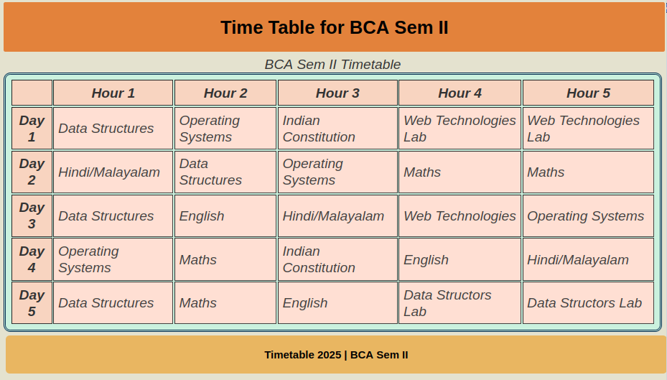

Program 7

Aim

Use‬ ‭all‬ ‭the‬ ‭CSS‬ ‭(inline,‬ ‭internal‬ ‭and‬ ‭external)‬ ‭to‬ ‭format‬ ‭the‬ ‭college‬ ‭web‬
page that you have created

Program

HTML

<!DOCTYPE HTML>
<html>
<head>

<meta name="viewport" content="width=device-width,initial-scale=1.0"/>
<title>St. George's College Aruvithura</title>
<link rel="stylesheet" type="text/css" href="css/pgm_7_styles.css">

<style>
body {
font-family: Arial, sans-serif;
background-color: ##f5f5dc;
}
h1 {
color: darkblue;
text-align: center;
}
nav {
background: #ebabaf;
padding: 10px;
text-align:center;
}
div {
padding: 20px;
background: #f7e7ce;
margin: 10px;
border-radius: 7px;
}
hr {
border: 1px solid #cccccc;
}
</style>
</head>

<body>
<div>
<h1 style="font-size: 32px;">St. George's College Aruvithura</h1>
</div>

<hr>
<nav>
<ul>
<li><a href="#about">About Our College</a></li>
<li><a href="#courses">Courses</a></li>
<li><a href="#departments">Departments</a></li>
<li><a href="#library">Library</a></li>
<li><a href="#location">Locate Us</a></li>
</ul>
</nav>
<hr>

<div id="about">
<h3>About College</h3>

<marquee> <h5>Ensuring academic excellence by imparting quality education and moulding personalities based on the love of God <h5> </marquee>

<p>St. George's College Aruvithura is a college under Mahatma Gandhi University, Kottayam. It is located in Aruvithura, Erattupetta, Kottayam District in Kerala, India. It was reaccredited with 'A++' Grade by NAAC for seven years in the fourth cycle.</p>

<p>St. George’s College Aruvithura, is a minority educational institution founded by St. George Forane Church, Aruvithura in 1965. Pioneered under the patronage of His Excellency Mar Sebastian Vayalil, the first Bishop of Pala, and cherished by a host of visionaries and philanthropists like Very Rev. Fr. Thomas Araythinal and Mr T. A. Thomman (Former Minister), the college, right from its inception, embarked on an odyssey towards academic pre-eminence. Very Rev. Fr. Thomas Manakkat, the founding manager and a great visionary, was truly instrumental in laying the foundations for a great beginning and Very Rev. Fr. Jacob Thazhathel, who followed him, was equally adept and insightful in his ideals, guiding the college during the early stages of its growth. For more than two decades, His Excellency Mar Joseph Pallickaparampil, the Bishop of Pala, had been the patron of the college. His Excellency Mar Joseph Kallarangattu is the present patron of this seat of learning.</p>

<p>Now the College offers instruction in Arts, Science, and Commerce. As of now, we have 15 undergraduate courses namely, Chemistry, Mathematics, Physics, Botany, Economics, Political Science, Commerce, English and Food Science and Quality Control (Self Financing) B.Com [Co-operation (SF)], BCA (SF), BA Mass Communication and Journalism and Five Post Graduate courses in Chemistry and Physics, Mathematics (SF), M.Com (SF), and M.Sc. Food Science and Technology (SF). An Integrated M.A. Programme in Languages English is also conducted here. The parents of students and the local population have been extending unconditional support for the onward progress of the College.</p>

<p>The College aims at the overall development of the students which would enable them to become ideal citizens of our country. The management, the faculty, and all the members of the non - teaching staff spare no pains to give all possible help for the spiritual, intellectual, moral, and academic excellence of the students put under the care of St. George, the Heavenly Patron.</p>
</div>
<hr>

<div id="departments">
<h3>Departments</h3>
<ul>
<li><a href="https://jzwn.github.io/BCA-LAB-Assignments/Lab/bca_dept.html" target="_blank">Department of Computer Applications (Aided)</a></li>
<li><a href="https://sgcaruvithura.ac.in/about-department?type=Department%20of%20Commerce%20(Aided)&department=13" target="_blank">Department of Commerce</a></li>
<li><a href="https://sgcaruvithura.ac.in/about-department?type=Department%20of%20Mathematics%20(SF)&department=31" target="_blank">Department of Mathematics</a></li>
</ul>
</div>
<hr>

<div id="courses">
<h3>Courses Offered</h3>
<ol>
<li>Bachelor of Computer Applications (BCA)</li>
<li>B.Com (Honours) with Specialization in Finance & Taxation</li>
<li>B.Sc (Honours) Mathematics</li>
<li>B.Sc (Honours) Chemistry</li>
<li>B.Sc (Honours) Botany</li>
<li>B.A (Honours) Political Science</li>
<li>B.Voc Food Technology & Analysis</li>
<li>B.Com (Honours) with Specialization in Finance & Taxation</li>
<li>B A (Honours) English with Specialization in Media Studies & Film Studies </li>
<li>B.Sc (Honours) Physics with specialization in Computational Physics and Semiconductor Physicss</li>
</ol>
</div>
<hr>

<div id="library">
<h3>Our Library</h3>
<p>The library at St. George's College, Aruvithura, has a rich history, having started functioning in 1965. Over the years, it has undergone significant upgrades and expansion to become a first-grade library. In 1978, the post of a first-grade Librarian and a IV-grade librarian were sanctioned, indicating the growing importance of the library as a vital academic resource.

Today, the library has a vast collection of resources to support the academic programs of the college. There are 32,330 books available on various subjects, including literature, science, technology, history, and philosophy. The library also has 58 periodicals, 250 CDs, and access to 8 newspapers, providing students and staff with access to the latest research and developments in their fields of interest.</p>
</div>
<hr>

<div id="location">
<h3>Locate Us</h3>
<iframe src="https://www.google.com/maps/embed?pb=!1m18!1m12!1m3!1d15731.91383638338!2d76.76682855568099!3d9.682879222712!2m3!1f0!2f0!3f0!3m2!1i1024!2i768!4f13.1!3m3!1m2!1s0x3b07cb05a55ae0e1%3A0x7b29e5e1e75aca3a!2sSt.%20George&#39;s%20Syro-Malabar%20Church%2C%20Aruvithura.!5e0!3m2!1sen!2sin!4v1739352757054!5m2!1sen!2sin" width="width=device-width" height="450" style="border:0;" allowfullscreen="" loading="lazy" referrerpolicy="no-referrer-when-downgrade"></iframe>
</div>

</body>
</html>

CSS

body {
font-family: Arial, sans-serif;
background-color: #f4f4f4;
}

div {
padding: 20px;
background: white;
margin: 10px;
border-radius: 5px;
}

h1 {
color: darkblue;
text-align: center;
font-size: 32px;
}

nav {
background: #333;
padding: 10px;
list-style: none;
}

nav {
display: block;
color: white;
padding: 10px;
}

hr {
border: 1px solid #cccccc;
}

Output
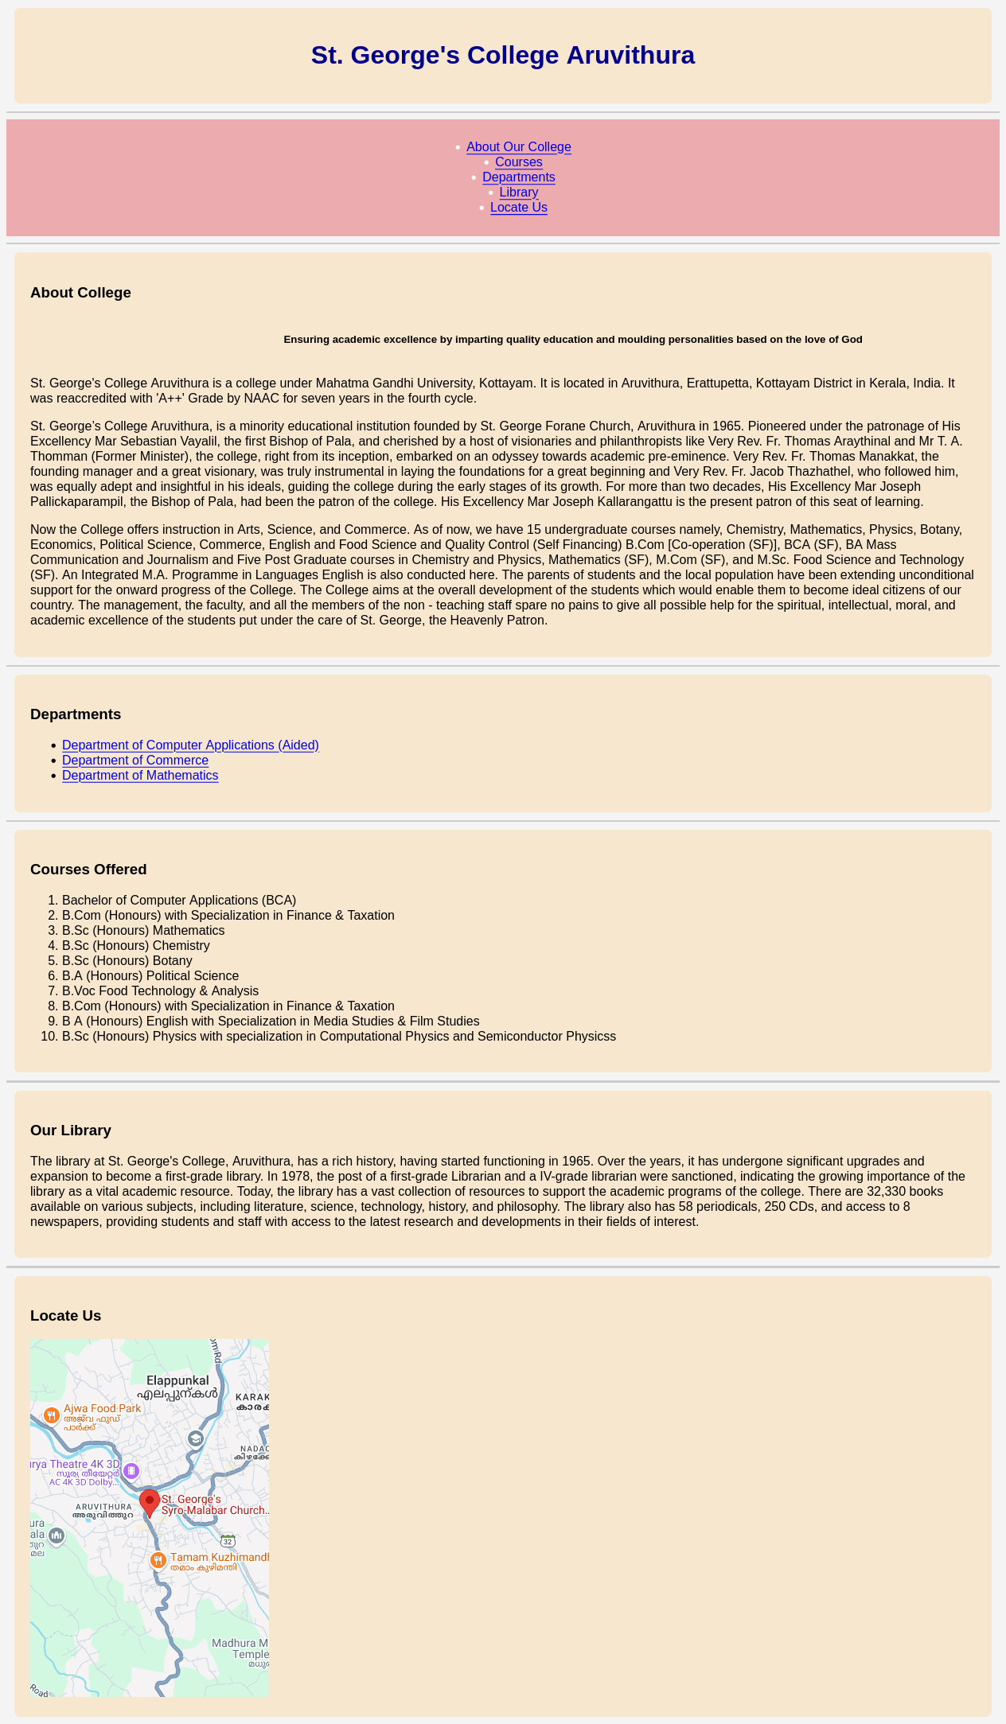

Program 8

Aim

Write a HTML Program to create your college website for mobile device

Program

HTML

<!DOCTYPE HTML>
<html>
<head>

<meta name="viewport" content="width=device-width,initial-scale=1.0"/>
<title>St. George's College Aruvithura</title>
<link rel="stylesheet" type="text/css" href="css/pgm_7_styles.css">

<style>
body {
font-family: Arial, sans-serif;
background-color: ##f5f5dc;
}
h1 {
color: darkblue;
text-align: center;
}
nav {
background: #ebabaf;
padding: 10px;
text-align:center;
}
div {
padding: 20px;
background: #f7e7ce;
margin: 10px;
border-radius: 7px;
}
hr {
border: 1px solid #cccccc;
}
</style>
</head>

<body>
<div>
<h1 style="font-size: 32px;">St. George's College Aruvithura</h1>
</div>

<hr>
<nav>
<ul>
<li><a href="#about">About Our College</a></li>
<li><a href="#courses">Courses</a></li>
<li><a href="#departments">Departments</a></li>
<li><a href="#library">Library</a></li>
<li><a href="#location">Locate Us</a></li>
</ul>
</nav>
<hr>

<div id="about">
<h3>About College</h3>

<marquee> <h5>Ensuring academic excellence by imparting quality education and moulding personalities based on the love of God <h5> </marquee>

<p>St. George's College Aruvithura is a college under Mahatma Gandhi University, Kottayam. It is located in Aruvithura, Erattupetta, Kottayam District in Kerala, India. It was reaccredited with 'A++' Grade by NAAC for seven years in the fourth cycle.</p>

<p>St. George’s College Aruvithura, is a minority educational institution founded by St. George Forane Church, Aruvithura in 1965. Pioneered under the patronage of His Excellency Mar Sebastian Vayalil, the first Bishop of Pala, and cherished by a host of visionaries and philanthropists like Very Rev. Fr. Thomas Araythinal and Mr T. A. Thomman (Former Minister), the college, right from its inception, embarked on an odyssey towards academic pre-eminence. Very Rev. Fr. Thomas Manakkat, the founding manager and a great visionary, was truly instrumental in laying the foundations for a great beginning and Very Rev. Fr. Jacob Thazhathel, who followed him, was equally adept and insightful in his ideals, guiding the college during the early stages of its growth. For more than two decades, His Excellency Mar Joseph Pallickaparampil, the Bishop of Pala, had been the patron of the college. His Excellency Mar Joseph Kallarangattu is the present patron of this seat of learning.</p>

<p>Now the College offers instruction in Arts, Science, and Commerce. As of now, we have 15 undergraduate courses namely, Chemistry, Mathematics, Physics, Botany, Economics, Political Science, Commerce, English and Food Science and Quality Control (Self Financing) B.Com [Co-operation (SF)], BCA (SF), BA Mass Communication and Journalism and Five Post Graduate courses in Chemistry and Physics, Mathematics (SF), M.Com (SF), and M.Sc. Food Science and Technology (SF). An Integrated M.A. Programme in Languages English is also conducted here. The parents of students and the local population have been extending unconditional support for the onward progress of the College.</p>

<p>The College aims at the overall development of the students which would enable them to become ideal citizens of our country. The management, the faculty, and all the members of the non - teaching staff spare no pains to give all possible help for the spiritual, intellectual, moral, and academic excellence of the students put under the care of St. George, the Heavenly Patron.</p>
</div>
<hr>

<div id="departments">
<h3>Departments</h3>
<ul>
<li><a href="bca_dept.html" target="_blank">Department of Computer Applications (Aided)</a></li>
<li><a href="https://sgcaruvithura.ac.in/about-department?type=Department%20of%20Commerce%20(Aided)&department=13" target="_blank">Department of Commerce</a></li>
<li><a href="https://sgcaruvithura.ac.in/about-department?type=Department%20of%20Mathematics%20(SF)&department=31" target="_blank">Department of Mathematics</a></li>
</ul>
</div>
<hr>

<div id="courses">
<h3>Courses Offered</h3>
<ol>
<li>Bachelor of Computer Applications (BCA)</li>
<li>B.Com (Honours) with Specialization in Finance & Taxation</li>
<li>B.Sc (Honours) Mathematics</li>
<li>B.Sc (Honours) Chemistry</li>
<li>B.Sc (Honours) Botany</li>
<li>B.A (Honours) Political Science</li>
<li>B.Voc Food Technology & Analysis</li>
<li>B.Com (Honours) with Specialization in Finance & Taxation</li>
<li>B A (Honours) English with Specialization in Media Studies & Film Studies </li>
<li>B.Sc (Honours) Physics with specialization in Computational Physics and Semiconductor Physicss</li>
</ol>
</div>
<hr>

<div id="library">
<h3>Our Library</h3>
<p>The library at St. George's College, Aruvithura, has a rich history, having started functioning in 1965. Over the years, it has undergone significant upgrades and expansion to become a first-grade library. In 1978, the post of a first-grade Librarian and a IV-grade librarian were sanctioned, indicating the growing importance of the library as a vital academic resource.

Today, the library has a vast collection of resources to support the academic programs of the college. There are 32,330 books available on various subjects, including literature, science, technology, history, and philosophy. The library also has 58 periodicals, 250 CDs, and access to 8 newspapers, providing students and staff with access to the latest research and developments in their fields of interest.</p>
</div>
<hr>

<div id="location">
<h3>Locate Us</h3>
<iframe src="https://www.google.com/maps/embed?pb=!1m18!1m12!1m3!1d15731.91383638338!2d76.76682855568099!3d9.682879222712!2m3!1f0!2f0!3f0!3m2!1i1024!2i768!4f13.1!3m3!1m2!1s0x3b07cb05a55ae0e1%3A0x7b29e5e1e75aca3a!2sSt.%20George&#39;s%20Syro-Malabar%20Church%2C%20Aruvithura.!5e0!3m2!1sen!2sin!4v1739352757054!5m2!1sen!2sin" width="width=device-width" height="450" style="border:0;" allowfullscreen="" loading="lazy" referrerpolicy="no-referrer-when-downgrade"></iframe>
</div>

</body>
</html>

CSS

body {
font-family: Arial, sans-serif;
background-color: #f4f4f4;
}

div {
padding: 20px;
background: white;
margin: 10px;
border-radius: 5px;
}

h1 {
color: darkblue;
text-align: center;
font-size: 32px;
}

nav {
background: #333;
padding: 10px;
list-style: none;
}

nav {
display: block;
color: white;
padding: 10px;
}

hr {
border: 1px solid #cccccc;
}

Output

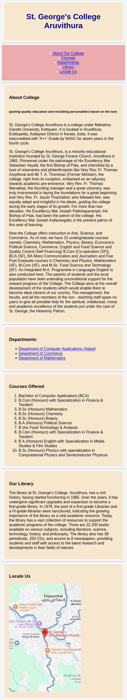

Program 9

Aim

Write an HTML/JavaScript page to create a login page with validations

Program

HTML

<!DOCTYPE html>
<html>
<head>
<title>Login</title>
<link rel="stylesheet" href="css/styles.css">
</head>
<body>
<h2>User Login</h2>
<p>Email : <input type="email" id="email"></p>
<p>Password : <input type="password" id="passwd"></p>
<input type="button" onclick="validate()" value="Login" class="bt">

<script src="script.js"></script>
</body>
</html>

JavaScript

function validate() {
let email_id = document.getElementById("email").value;
let password_value = document.getElementById("passwd").value;

if(email_id == "")
{
alert("Email Cannot be empty :(");
}
else if (password_value == "")
{
alert("password Cannot be empty :(");
}
else if (password_value.length < 8)
{
alert("Minimum 8 Characters required for password :(");
}
else
{
alert("Form Validation Success :)");
}
}

Output

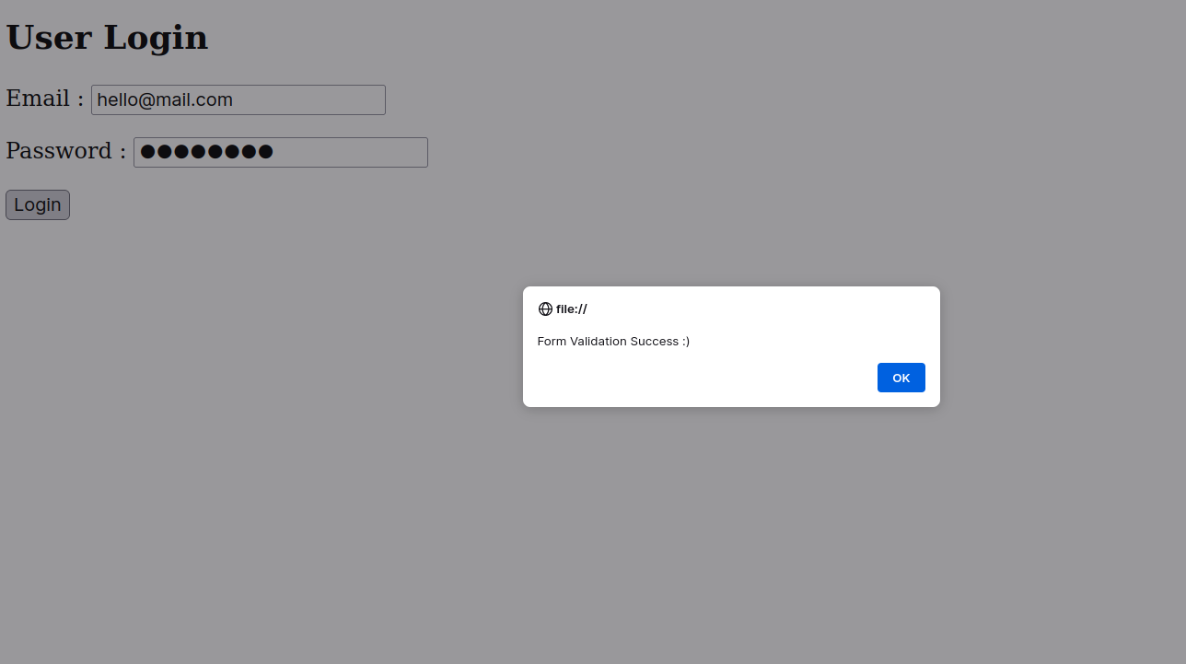

Program 10

Aim

Develop‬‭ a‬‭ Simple‬‭ calculator‬‭ for‬‭ addition,‬‭ subtraction,‬‭ multiplication‬‭ and‬
division operation using JavaScript

Program

HTML

<!DOCTYPE html>
<html>
<head>
<title>Calculator</title>
<link rel="stylesheet" href="css/styles.css">
</head>
<body>

<h1>Calculator</h1>

<input type="text" size="4" class="inp" id="inp1">
<input type="text" size="4" class="inp" id="inp2">

<br><br>

<input type="button" onclick="addSum()" value="+" class="bt">
<input type="button" onclick="substract()" value="-" class="bt">

<input type="button" onclick="multiplication()" value="*" class="bt">

<input type="button" onclick="divide()" value="/" class="bt">

<br><br>

<span id="ans" class="box">0</span>

<script>

function addSum()
{
var a=Number (document.getElementById("inp1").value);
var b=Number (document.getElementById("inp2").value);
var c=a+b;
document.getElementById("ans").innerHTML=c;
}

function substract()
{
var a=Number (document.getElementById("inp1").value);
var b=Number (document.getElementById("inp2").value);
var c=a-b;
document.getElementById("ans").innerHTML=c;
}

function multiplication()
{
var a=Number (document.getElementById("inp1").value);
var b=Number (document.getElementById("inp2").value);
var c=a*b;
document.getElementById("ans").innerHTML=c;
}

function divide()
{
var a=Number (document.getElementById("inp1").value);
var b=Number (document.getElementById("inp2").value);
var c=a/b;
document.getElementById("ans").innerHTML=c;
}

</script>
</body>
</html>

CSS

body{
text-align:center;
}
.inp{
width:100px;
height:100px;
font-size:30px;
text-align:center;
}
.bt{
width:80px;
height:40px;
font-size:30px;
background-color:#00bcd4;
border:none;
border-radius:25px;
}
#op{
font-size:30px;
}
#ans{
font-size:30px;
}

#ans{
width:80px;
height:40px;
font-size:30px;
border:none;
border-radius:25px;
}

Output

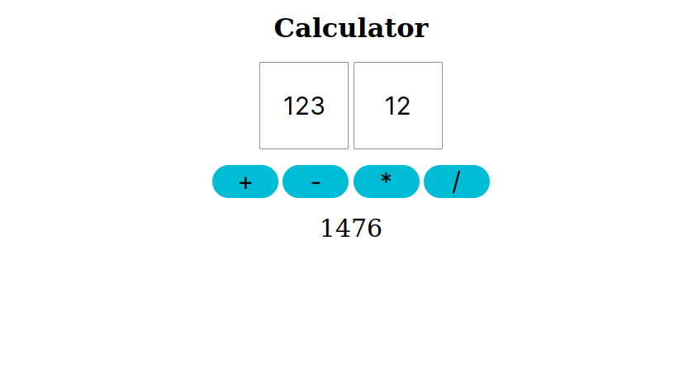

Program 11

Aim
Use Regular Expressions for validations in Login Page using JavaScript
Program

HTML

<!DOCTYPE html>
<html>
<head>
<title>Login</title>
<link rel="stylesheet" href="css/styles.css">
</head>
<body>

<h2>User Login</h2>
<p>Email : <input type="email" id="email"></p>
<p>Password : <input type="password" id="passwd"></p>
<input type="button" onclick="validate()" value="Login" class="bt">

<script src="script.js"></script>
</body>
</html>

CSS

function validate() {
let email_id = document.getElementById("email").value;
let password_value = document.getElementById("passwd").value;

let email_pattern = /^.+@.+$/;

if(email_id == "")
{
alert("Email Cannot be empty :(");
}
else if (!email_pattern.test(email_id))
{
alert("Invalid Email Format :(");
}
else if (password_value == "")
{
alert("password Cannot be empty :(");
}
else if (password_value.length < 8)
{
alert("Minimum 8 Characters required for password :(");
}
else
{
alert("Form Validation Success :)");
}
}

Output

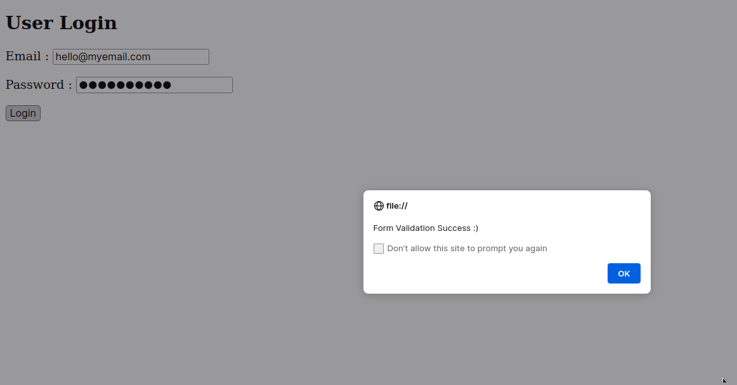

Program 12
Aim
Write‬ ‭a‬ ‭Program‬ ‭to‬ ‭retrieve‬ ‭date‬ ‭from‬ ‭a‬ ‭text‬ ‭file‬ ‭and‬ ‭display‬ ‭it‬ ‭using‬ AJAX

Program
<!DOCTYPE HTML>
<html>
<head>
<title>AJAX Data retrival</title>
</head>
<body>
<input type="button" value="Submit" id="submitBtn" onclick="loadData()">
<p> Data is : <span id="dateDisplay"> </span><p>

<script>

function loadData()
{
let xhr= new XMLHttpRequest();
xhr.open("GET","data.txt",true);

xhr.onload=function()
{
if(xhr.status == 200)
{
document.getElementById("dateDisplay").innerText=xhr.responseText;
}
};
xhr.send();
}

</script>
</body>
</html>

Output

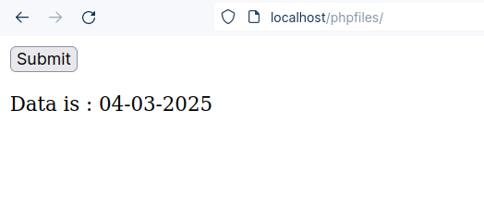

Program 13

Aim

Create‬ ‭a‬ ‭web‬ ‭page‬ ‭using ‬‭Frame‬‭ with‬‭ rows ‬‭and‬‭ columns ‬‭where‬‭ we ‬‭will‬ have‬ ‭header‬ ‭frame,‬ ‭left‬ ‭frame,‬ ‭right‬ ‭frame,‬ ‭and‬ ‭status‬ ‭bar‬ ‭frame.‬ ‭On‬ clicking in the left frame, information should be displayed in the right frame
Program

index.html

<!doctype html>
<html lang="en-US">
<head>
</head>
<frameset rows="20%,*,10%">
<frame name="header" src="header_frame.html" />

<frameset cols="30%,70%">
<frame name="left" src="left_frame.html" />
<frame name="right" src="https://sgcaruvithura.ac.in/" />
</frameset>

<frame name="bottom" src="status_frame.html" />
</frameset>
</html>

header_frame.html

<!DOCTYPE html>
<html>
<head>
<title>Heading</title>
</head>
<body bgcolor="#00BCD4">
<h2 style="color:white; text-align: center;">
Welcome To Easy Links Example
</h2>
<h5 style="color:white; text-align: center;"> Select an option from the left panel to easily access it</h5>
</body>
</html>

left_frame.html

<!DOCTYPE html>
<html>
<head>
<title>Left Frame</title>
</head>
<body bgcolor="#D3D3D3">
<ul>

<li><a href="https://sgcaruvithura.ac.in/about-department?type=Department%20of%20Computer%20Applications%20(Aided)&department=14" target="right">BCA Department</a></li>
<br>
<li><a href="https://sgcaruvithura.ac.in/library" target="right">Library</a></li>
<br>
<li><a href="https://sgcaruvithura.ac.in/sgc-tv" target="right">SGC TV</a></li>

</ul>
</body>
</html>

status_frame.html

<!DOCTYPE html>
<html>
<head>
<title>Status Frame</title>
</head>

<body bgcolor="#4a7d49">
<h5 style="color:white; text-align: center;">
Thankyou For Visiting
</h5>
<h7 style="color:white; text-align: center;"> Designed By jzwn</h7>
</body>
</html>

Output
